**Validation of vegetation biophysical variables retrievals from The Simplified Level 2 Product Prototype Processor (SL2P) and Landsat-8 data**

1. Introduction
2. Study sites and materials.
   1. In-situ reference measurements

In-situ reference measurements acquired within the National Ecological Observatory Network (NEON) across North America and Canada Centre for Remote Sensing (CCRS) - Natural Resources Canada’s Cumulative Effects study sites across Canada are used.

NEON sites included a wide range of vegetation types as defined by the National Land Cover Database (NLCD, [National Land Cover Database | U.S. Geological Survey (usgs.gov)](https://www.usgs.gov/centers/eros/science/national-land-cover-database)) classification: evergreen forest (EF), deciduous forest (DF), mixed forest (DF), cultivated crops (CC), emergent herbaceous wetlands (EHW), grassland herbaceous (GH), pasture hay (PH), sedge herbaceous (SH), shrub scrub (SS), woody wetlands (WW), and dwarf scrub (DS). While CCRS sites included EF, CF and MF classes.

Figure 1 shows the location of both NEON and CCRS sites, as well as the dominant land cover for each site. More details are provided in Table xx of the Appendix.

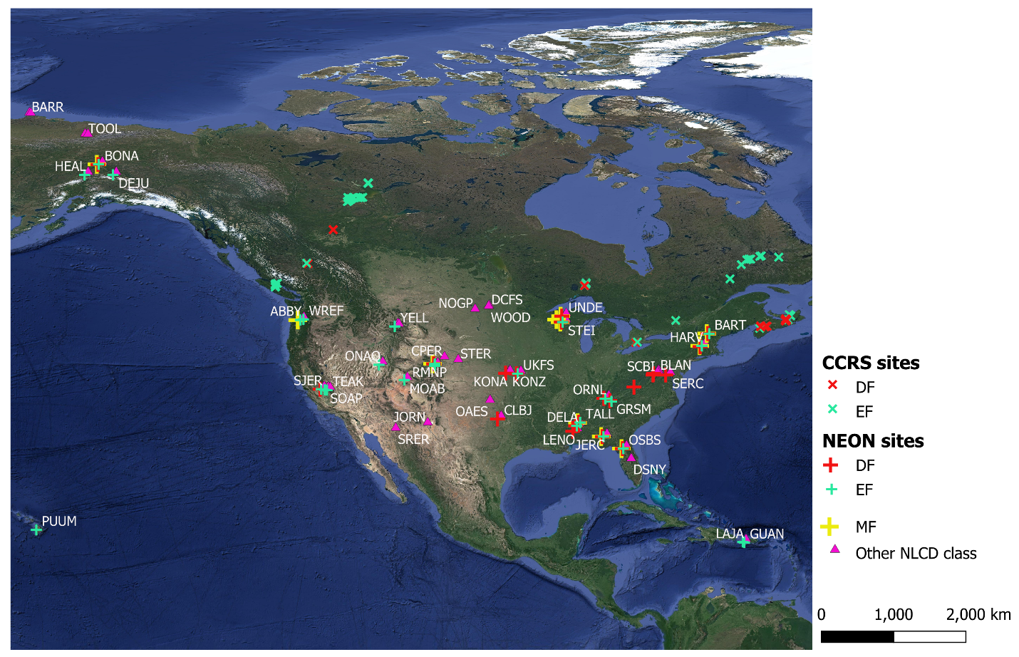

Figure 1: NEON and CCRS study sites.

For NEON sites, fraction of intercepted PAR (fIPAR), fCOVER, and LAI reference measures were derived from estimates of gap fraction obtained using DHPs 634 ESUs in 47 sites across North America. For each site, at least three 20 m by 20 m square ESUs were sampled bi-weekly from leaf-out to senescence for periods ranging from 3 to 6 years (Table ##). In each ESU, 12 co-located upward and downward looking DHP images were acquired with 4 m spacing in North-South and East-West transects through the plot centre using 36.3MPixel Nikon D810 or D800 cameras with a Nikon 16 mm Fisheye lens giving a 180◦ diagonal field of view. Upwards and downward images were processed separately. PAI was estimated as the average of effective PAI (${PAI}_{e}$) estimates for 10 $°$ azimuthal intervals within ${57.5}^{°}±5°$ zenith angle to minimize sensitivity to leaf angle (Miller, 1967). The effective PAI for each azimuth angle was estimated as twice the negative logarithm of the gap fraction multiplied by the cosine of the zenith angle. fIPAR (fCOVER) was estimated as one minus the mean gap fraction within ±5◦ of the solar zenith angle at 10:00 local solar time (±5◦ of nadir).

CCRS data are acquired for 133 ESUs in 11 forested sites. ESUs were located within the dominant land cover types at each site with replication where logistics permitted. For each ESU, seven co-located upward and downward DHP images were acquired every 5 m along two parallel transects spaced 15 m apart using 45.7 Mpixel Nikon D850 cameras with a Nikon 8 mm Fisheye lens giving a 180◦ FOV in all directions. DHPs for each ESU sampling date were visually quality controlled, contrast enhanced using ViewNXi software and masked to remove the field operator. CANEYE V6.45, using the same approach as GBOV, was used to derive PAI, fCOVER and fAPAR as well as the associated 1σ uncertainties for each upward or downward DHP image.

* 1. Satellite data

Landsat-8/OLI (L8) and Sentinel-2/MSI (S2) surface reflectance data are extracted from Google Earth Engine (GEE) collections LANDSAT/LC08/C02/T1_L2 and COPERNICUS/S2_SR_HARMONIZED respectively. More details about data extraction are presented in section ###.

L8 is part of the Landsat Data Continuity Mission (Irons et al., 2012), launched by the European Space Agency on February 11, 2013. It has a sun-synchronous orbit at an altitude of ~705 km, with approximately 16-day revisit of the Earth and an equatorial overpass time of approximately10:15 a.m. (descending node). It carries the Operational Land Imager (OLI) that has eight spectral bands at 30m spatial resolution covering the visible, the near infrared (NIR) and the shortwave-infrared (SWIR) spectral regions, and one 15m spatial resolution panchromatic band. L8 surface reflectance data are estimated (atmospheric effects correction) using Landsat Surface Reflectance Code (LaSRC).

S2 is a constellation of satellites, S2-A and S2-B, launched by the European Space Agency (ESA) on 23 June 2015 and 7 March 2017, respectively. They occupy the same sun-synchronous orbit at an altitude ~786 km but separated by 180°. Together, they provide better than 5-day revisit of the Earth's land surfaces with an equatorial overpass time at approximately10:30 a.m. (descending node). S2-A and S2-B carry a virtually identical decametric resolution Multi-Spectral Imager (MSI) covering the visible, the near infrared (NIR) and the shortwave-infrared (SWIR) spectral regions. S2 surface reflectance data are obtained by correcting atmospheric effects on to-of-atmosphere reflectance using the Sen2Cor processor (Version 2.4.0, Mueller-Wilm et al., 2017).

1. Methodology
   1. Reference measurement estimation

PAI, fIPAR and fCOVER estimates obtained from downward and upward DHPs were converted to LAI, fAPAR and green fCOVER, respectively, by multiplying quantities by the corresponding woody area to total area ratios given in Table ***. For the understory values, a ratio of 0.05 was selected assuming herbaceous and shrub understory cover have non-zero woody to total area ratio that is typically less than trees due to absence of trunks.

The total LAI, fAPAR and fCOVER reference measures were estimated by combining understory and overstory values.

Table ##: woody area to total area ratios

|  |  |  |
| --- | --- | --- |
| Land cover | Overstory | Understory |
| Evergreen | 0.16 (0.10) | 0.05 |
| Deciduous | 0.24 (0.11) | 0.05 |
| Mixed | 0.18 (0.11) | 0.05 |
| Others | 0.10 (0.11) | 0.05 |

* 1. Reference data filtering

Moving window filtering approach was used to reduce outliers on NEON’s RM data; considering a RMs time-series for a given variable $V$ acquired on a specific ESU (an example is provided in Figure ## in the Appendix), each observation $RM$ is compared to the closest 2 enveloping quantities ${RM}_{l}$ and ${RM}_{r}$ observed within +/- 15-days when exists. Outlier flag was raised when the following three conditions are simultaneously satisfied:

$$\left|RM- {RM}_{l}\right|>\max{({RM}_{U},ε_{V})}$$

$$\left|RM- {RM}_{r}\right|>\max{({RM}_{U},ε_{V})}$$

$$\left(RM- {RM}_{l}\right). \left(RM- {RM}_{r}\right)>0$$

With ${RM}_{U}$ is the uncertainty of $RM$ and $ε_{V}$ is an empirical threshold fixed for each vegetation variable V. In total, less than 1% of the available RMs are detected as outliers (0.31% for LAI, 0.97% for fCOVER and 0.93% and fAPAR, see Table ## in Appendix).

* 1. Vegetation variables estimation from satellite data

Canada Centre for remote Sensing version of the Simplified Level 2 Prototype Processor (SL2P-CCRS, Fernandes et al., 2024) implemented in Google Earth Engine within the Landscape Evolution And Forecasting (LEAF) Toolbox (Fernandes et al., 2021) is used to retrieve vegetation variables estimates from L8 and S2 surface reflectance data. Briefly, SL2P is a collection of back-propagation artificial neural networks (ANN) trained using a globally representative set of simulations from a canopy radiative transfer model (RTM) based on joint distributions of leaf, canopy, soil, and acquisition geometry conditions. It is designed to estimate leaf area index (LAI), the fraction of absorbed photosynthetically active radiation (fAPAR), the fraction of vegetation cover (FCOVER), canopy chlorophyll content (CCC), and canopy water content (CWC) as well as their theoretical uncertainty from medium resolution multispectral satellite data. SL2P-CCRS defers from SL2P by (1) using land cover specific regressions instead of a single regression irrespective of land cover, (2) using 4SAIL2 instead of SAILH to account for foliage clumping within shoots, and (3) using Sobol model, instead of orthogonal sampling, for sampling canopy parameters from the joint distribution of input parameters.

SL2P-CCRS estimates of LAI, fCOVER and fAPAR associated with their quality control flags are retrieved from L8 and S2 data for the different available reference samples. Valid SL2P-CCRS estimates for clear sky land pixels whose centroid fell within a 30 m (20 m) radius for L8 (S2) (i.e. 3x3 pixels window) from the centre of each ESU and ± 7 days interval from the DHP acquisition date are extracted; the median value is considered as an aggregate. Only satellite images with cloud cover less than 90% are considered. LaSRC and Sen2Cor cloud products are used for masking cloud from L8 and S2 images respectively. S2 cloud probability product (S2cloudless, GEE collection 'COPERNICUS/S2_CLOUD_PROBABILITY’) is also applied on S2 products for filtering more cloudy pixels. Remaining clear sky ******

* 1. Cross-validation

LAI, fCOVER and fAPAR estimates obtained from L8 and S2 data using SL2P-CCRS are compared to RMs for ten different NLCD land covers: evergreen forest, deciduous forest, mixed forest, cultivated crops, emergent herbaceous wetlands, grassland herbaceous, pasture hay, sedge herbaceous, shrub scrub, woody wetlands. Dwarf scrub samples are excluded for …..

For each variable, the accuracy (A), the uncertainty (U), and the precision (P), the coefficient of determination (R2) as well as the uncertainty agreement ratio (UAR) of estimates obtained using SL2P-CCRS from L8 and S2 data were computed for the entire RMs (Eq: 1, 2, 3 and 4).

$$A=\frac{1}{N}\sum_{i=1}^{N}{(\hat{y_{i}}-y_{i})}$$

$$U=\sqrt[2]{\frac{1}{N}\sum_{i=1}^{N}{{(\hat{y_{i}}-y_{i})}^{2}}}$$

$$P=\sqrt[2]{\frac{1}{N}\sum_{i=1}^{N}{{(\hat{y_{i}}-y_{i}-A)}^{2}}}$$

$$R^{2}={\left[\frac{\sum_{i=1}^{N}{\left(y_{i}-\overline{y}\right).\left(\hat{y_{i}}-\overline{\hat{y}}\right)}}{\sqrt[2]{\sum_{i=1}^{N}{{\left(y_{i}-\overline{y}\right)}^{2}}}.\sqrt[2]{\sum_{i=1}^{N}{{\left(\hat{y_{i}}-\overline{\hat{y}}\right)}^{2}}}}\right]}^{2}$$

$$UAR=\frac{1}{N}\sum_{i=1}^{N}{I (\left|\frac{\hat{y_{i}}-y_{i}}{y_{i}}\right|}≤ε_{rel}∪ \left|\hat{y_{i}}-y_{i}\right|≤ε_{max})$$

where, $\hat{y_{i}}$, $y_{i}$ ($\overline{y}$, $\overline{\hat{y}}$) are, respectively, the SL2P-CCRS estimate and RM for the ith of N comparisons (the corresponding average), and $ε_{rel}$, $ε_{max}$ are, respectively, the relative and maximum target uncertainty requirement and I is the indicator function.

Additionally, as suggested by Global Leaf Area Index Product Validation Good Practices (Fernandes et al., 2014), thematic error metrics (A, P, U) are plotted as a function of the RM value by considering a third order polynomial weighted least squares regressions fitted to quantities based on residuals between the mean of matching RM values and the corresponding SL2P-CCRS estimates as detailed in Fernandes et al. (2024).

* 1. Estimates temporal stability.

Word Meteorological Organization defined the stability as “The change in bias over time”. It is a factor of uncertainties to demonstrate that the estimation error remains constant over the period, typically a decade or more. In this study, the slope from annual estimates bias (accuracy) was computed as an indicator.

The temporal spatiality of LAI, fCOVER and fAPAR SL2P-CCRS estimates from both L8 and S2 data was investigated first for all sites together, then for each single site. For the later, only sites with at least 3-years of data and at least 3-mutchps each year are considered.

1. Results
   1. Cross-validation

Scatter plots of LAI, fCOVER and fAPAR estimates obtained using SL2P-CCRS from L8 and S2 against the corresponding RMs are showed in Figure 2. Table ## presents the number of matchups and variation range of RM used for the validation of estimates obtained from L8 and S2 data for each NLCD class.

A total of 6313 matching was found between SL2P-CCRS estimates obtained from L8 data and reference samples (Figure 2a), compared to #4935 matching when using S2 (Figure 2b) . LAI, fCOVER and fAPAR RM ranges from 0 to 5.96, from 0 to 0.96, and from 0 93 for samples corresponding to L8 estimates, and from 0 to 6.87, from 0 to 0.99, and from 0 to 0.95 for samples corresponding to L8 estimates.

Figures 2.a and 2.b. indicates that despite a relatively linear relationships between estimates and RM (R2 ~0.75), SL2P-CCRS underestimate LAI whether using L8 (A=-0.52) or S2 (A=-0.45) data. This explains the high uncertainty (1.30 for L8 and 1.24 for S2) and the low UAR (0.09 for L8 and 0.12 for S2) of estimates. This is an expected result since SL2P-CCRS is not properly accounting for clumping. Conversely, fCOVER estimates are ~unbiased whatever the used sensor, and ~equal uncertainty (~0.15), R2 (0.75) and UAR (0.35) quantities are obtained for estimates from L8 and S2. SL2P-CCRS fAPAR estimates are slightly underestimated (A=-0.04). But, again, ~equal uncertainty (0.17), R2 (~0.71) and UAR (0.32) qualities are obtained when using L8 or S2 data.

Considering cover type specific statistics, computed with unbalanced sample sizes, SL2P-CCRS estimates are underestimated irrespective to the used sensor or the variable for woody wetlands, evergreen forest, deciduous forest, and mixed forest: from-1.87 to -0.78 for LAI, from -0.12 to -0.01 for fCOVER, and from -0.19 to -0.08 for fAPAR. While estimates are overestimated for the other croplands: from 0.17 to 1.16 for LAI, from 0.06 to 0.33 for fCOVER, and from 0.05 to 0.31 for fAPAR. The underestimation is higher for woody wetlands, and the overestimation is higher for sedge herbaceous.

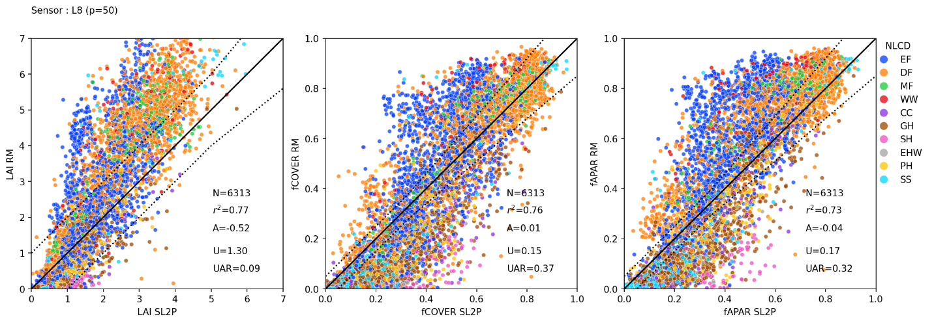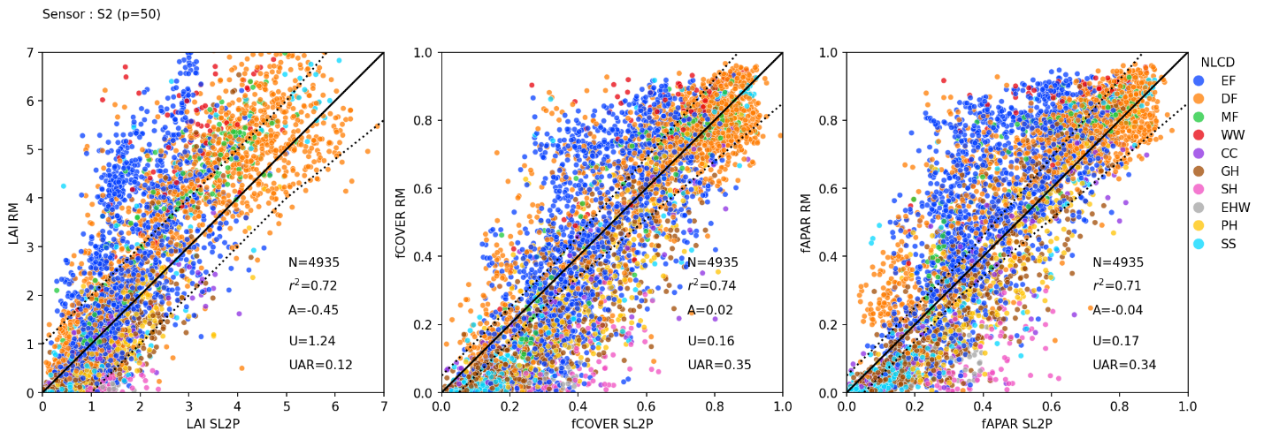

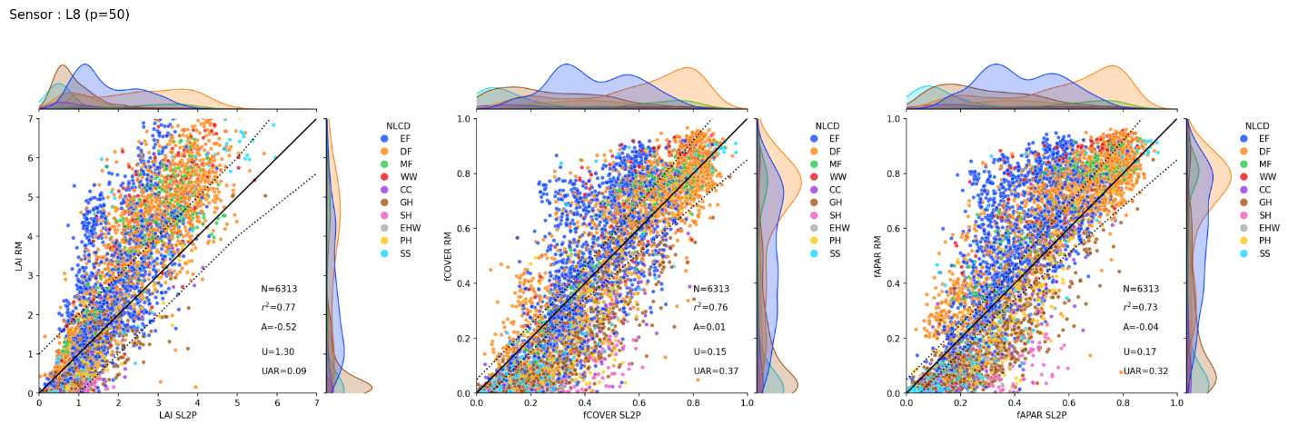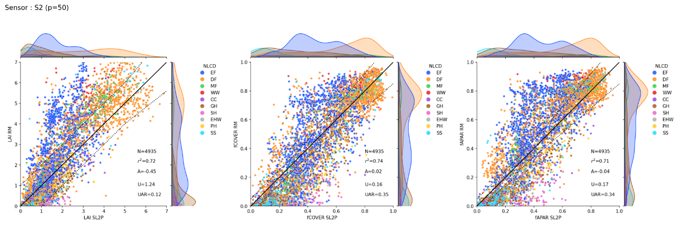

Figure 2: Scatter plots of ESU SL2P-CCRS estimates versus matching RM for each variable together with population validation metrics. Dashed lines bound target user requirement around solid 1:1 line.

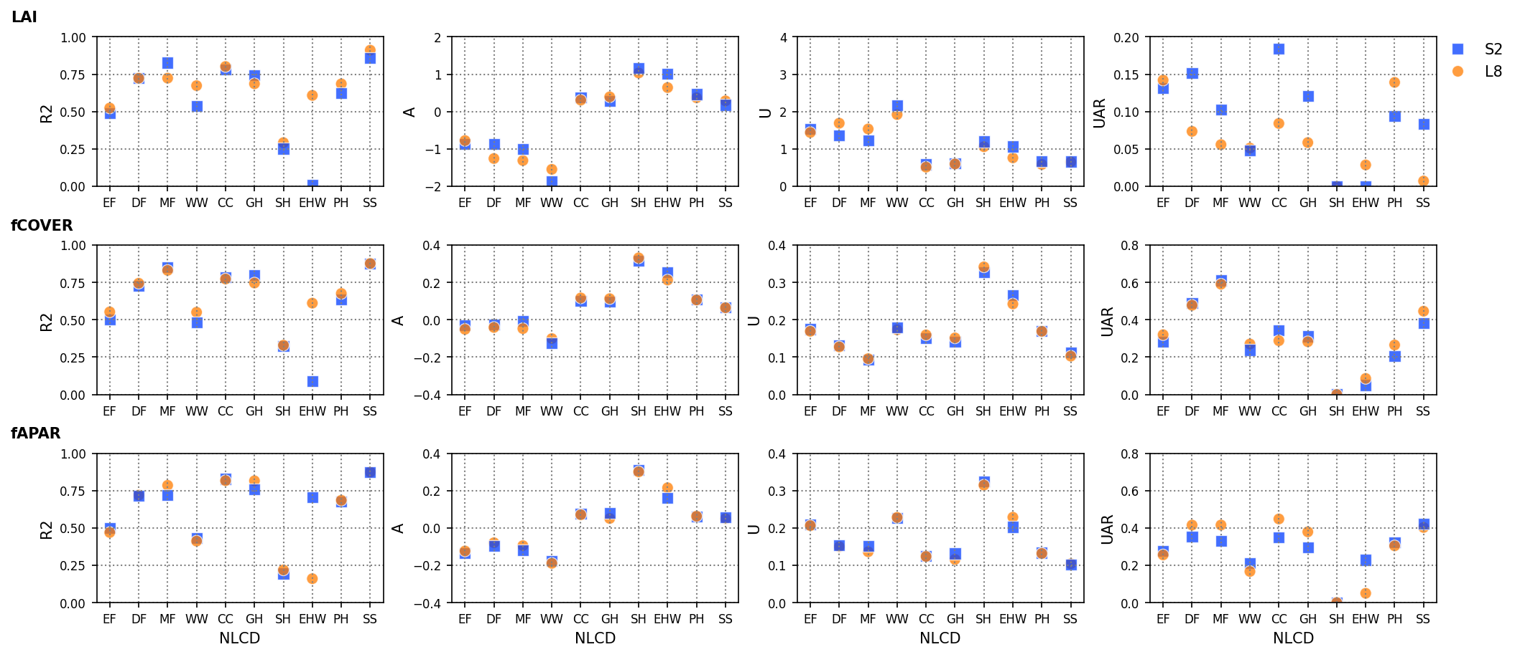

Figure 3: Validation metrics per landcover type for LAI, fCOVER and fAPAR SL2P-CCRS estimates from L8 and S2 data against RMs.

|  |  |  |  |  |  |  |  |  |  |
| --- | --- | --- | --- | --- | --- | --- | --- | --- | --- |
|  | LAI | | | fCOVER | | | fAPAR | | |
| **NLCD** | **MIN** | **MAX** | **N** | **MIN** | **MAX** | **N** | **MIN** | **MAX** | **N** |
| EF | 0.01 | 4.48 | 1788 | 0.01 | 0.87 | 1788 | 0.02 | 0.85 | 1788 |
| DF | 0.04 | 5.67 | 1716 | 0.03 | 0.95 | 1716 | 0.04 | 0.92 | 1716 |
| MF | 0.51 | 4.70 | 305 | 0.18 | 0.89 | 305 | 0.17 | 0.86 | 305 |
| WW | 0.57 | 5.43 | 137 | 0.19 | 0.88 | 137 | 0.18 | 0.85 | 137 |
| CC | 0.11 | 4.13 | 226 | 0.00 | 0.84 | 226 | 0.03 | 0.84 | 226 |
| GH | 0.10 | 5.71 | 1095 | 0.00 | 0.94 | 1095 | 0.01 | 0.91 | 1095 |
| SH | 0.71 | 1.88 | 67 | 0.22 | 0.61 | 67 | 0.21 | 0.60 | 67 |
| EHW | 0.58 | 2.02 | 35 | 0.13 | 0.58 | 35 | 0.16 | 0.60 | 35 |
| PH | 0.57 | 3.81 | 374 | 0.04 | 0.84 | 374 | 0.03 | 0.83 | 374 |
| SS | 0.20 | 5.96 | 570 | 0.00 | 0.96 | 570 | 0.00 | 0.93 | 570 |
| **All** | **0.01** | **5.96** | **6313** | **0.00** | **0.96** | **6313** | **0.00** | **0.93** | **6313** |

|  |  |  |  |  |  |  |  |  |  |
| --- | --- | --- | --- | --- | --- | --- | --- | --- | --- |
|  | LAI | | | fCOVER | | | fAPAR | | |
| **NLCD** | **MIN** | **MAX** | **N** | **MIN** | **MAX** | **N** | **MIN** | **MAX** | **N** |
| EF | 0.16 | 5.00 | 1558 | 0.05 | 0.87 | 1558 | 0.06 | 0.84 | 1558 |
| DF | 0.08 | 6.87 | 1330 | 0.01 | 0.99 | 1330 | 0.04 | 0.95 | 1330 |
| MF | 0.29 | 5.22 | 195 | 0.03 | 0.92 | 195 | 0.01 | 0.89 | 195 |
| WW | 0.63 | 5.31 | 84 | 0.17 | 0.89 | 84 | 0.18 | 0.88 | 84 |
| CC | 0.01 | 4.03 | 163 | 0.00 | 0.90 | 163 | 0.01 | 0.88 | 163 |
| GH | 0.00 | 4.95 | 747 | 0.00 | 0.90 | 747 | 0.00 | 0.85 | 747 |
| SH | 0.74 | 2.37 | 79 | 0.18 | 0.64 | 79 | 0.19 | 0.62 | 79 |
| EHW | 0.16 | 1.88 | 40 | 0.03 | 0.41 | 40 | 0.04 | 0.41 | 40 |
| PH | 0.15 | 4.86 | 319 | 0.06 | 0.88 | 319 | 0.08 | 0.86 | 319 |
| SS | 0.00 | 6.08 | 420 | 0.00 | 0.92 | 420 | 0.00 | 0.90 | 420 |
| **All** | **0.00** | **6.87** | **4935** | **0.00** | **0.99** | **4935** | **0.00** | **0.95** | **4935** |

* 1. Accuracy, precision, and uncertainty as a function of RM value (APU curves)

Figure 4 shows APU curves for LAI, fCOVER and fAPAR SL2P-CCRS estimates from L8 and S2 data, as well as histograms of data samples used to fit APU models. The increased sample density of data for the different variable’s levels (in average 800 S2 and 600 L8 samples used for LAI, 600 S2 and 400 L8 samples used for fCOVER and fAPAR) explains the narrow confidence interval of APU models obtained for each variable. Wider confidence intervals are for the highest variables’ levels (i.e. LAI>6, fCOVER>0.9, and fAPAR>0.9) due to the lower sample density (i.e. ~200 samples for LAI, ~100 samples for fCOVER and ~180 samples for fAPAR, regardless the sensor).

APU curves associated to estimates from L8 data compares well with the corresponding curves obtained for estimates from S2 data, regardless the vegetation variable.

LAI estimates uncertainty ~linearly increases from ~0 for LAI ~0 to ~3 for LAI~7; it satisfies GCOS requirements only for LAI<3. In contrast, the accuracy ~linearly decreases from ~0 for LAI~0 to ~-3 for LAI~7. Whereas the precision remains ~stable and lower than 1 for all ranges. The accuracy and the precision of estimates from L8 are found slightly lower than the corresponding quantities from S2, in contrast to the uncertainty which is slightly higher for L8.

For fCOVER, the accuracy and the uncertainty simultaneously increase from ~0.1 to ~0.15 for the range 0 - 0.2, then decrease to ~-0.1 (accuracy) and ~0.1 (uncertainty) for the range 0.2-0.8, and finally increase to ~-0.5 (accuracy) and 0.2 (uncertainty) for the range 0.8-1. The precision remains ~ stable (~0.1) for the entire range. Target uncertainty requirements are only satisfied for fCOVER levels from 0.5 to 0.9.

For fAPAR, the accuracy decreases from ~ 0.2 for fAPAR~0 to ~-0.2 for fAPAR~1. While the uncertainty decreases from ~0.2 to ~0.1 for the range 0 - 0.5, then it increases back from ~0.1 to ~0.2 for the range 0.5 - 1. Whoever, the precision, as for LAI and fAPAR, remains ~stable for the entire range.

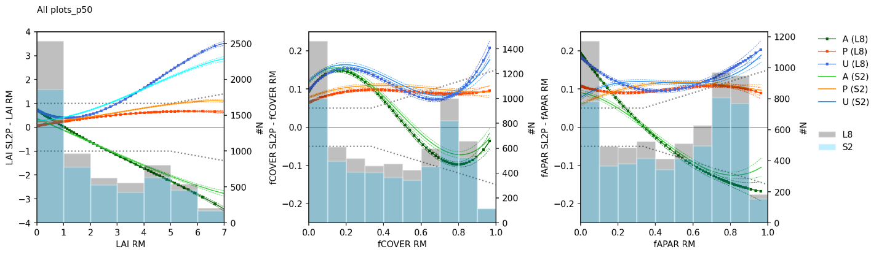

Figure 4: APU curves and the corresponding 95% confidence intervals (dashed contours) for LAI, fCOVER and fAPAR estimates obtained using SL2P-CCRS from S2 and L8 data. Dashed grey lines bound target user requirements.

* 1. Temporal stability of vegetation variable estimates

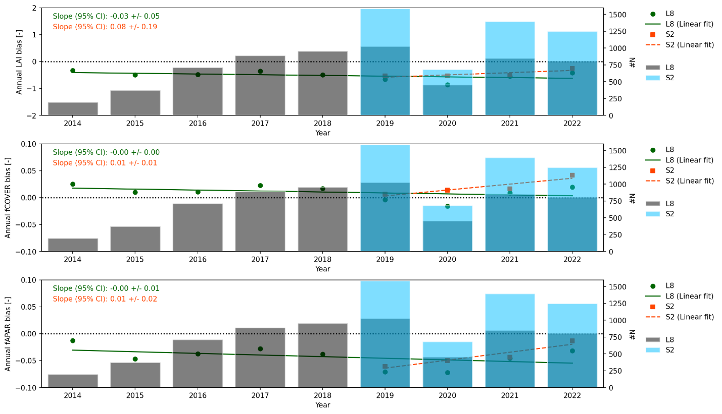

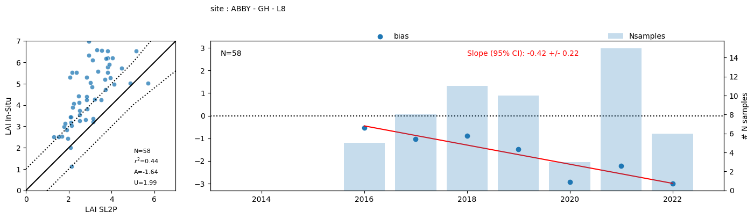

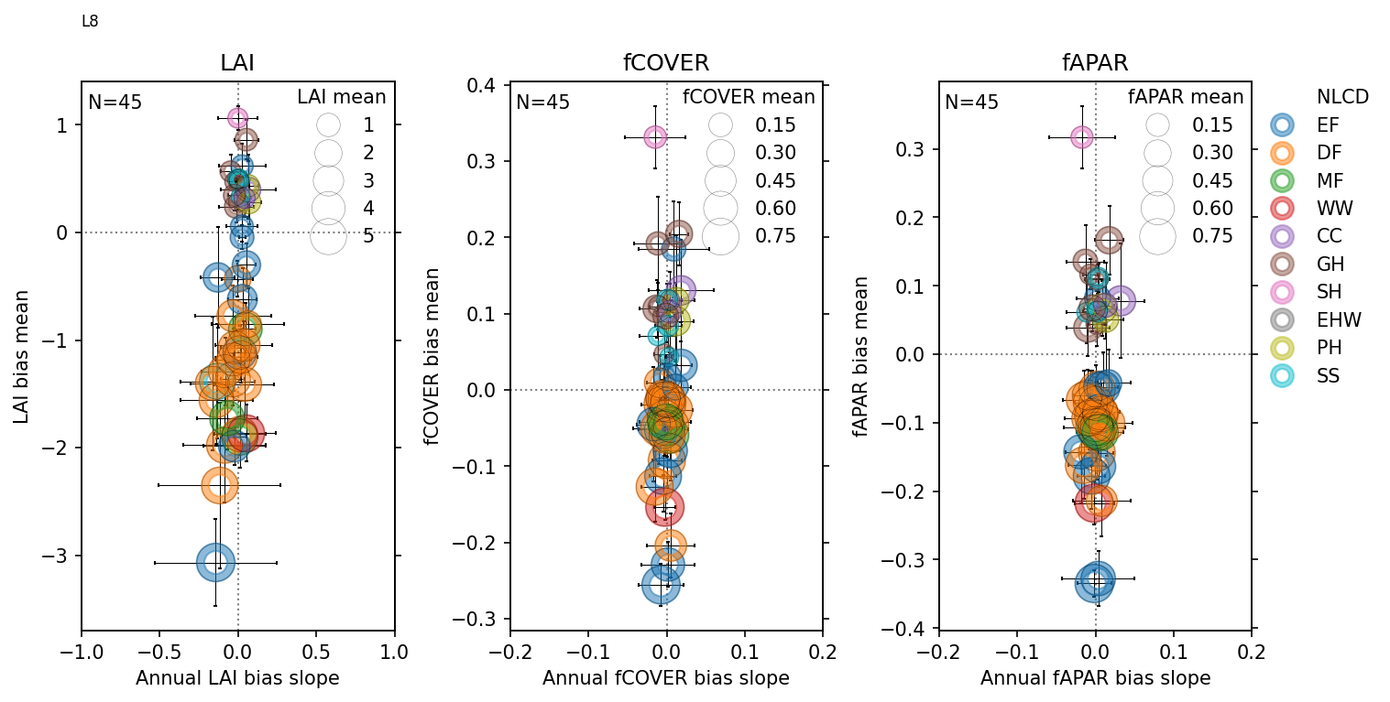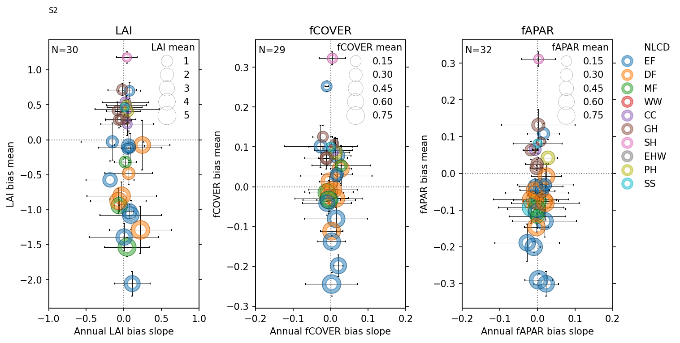

Appendix:

1. CCRS and NEON site used for the study.

|  |  |  |  |  |  |  |
| --- | --- | --- | --- | --- | --- | --- |
| **Site** | **Network** | **#ESUs** | **Start Date** | **End Date** | **#sample** | **NLCD (#sample)** |
| Peace River | CCRS | 3 | 2019-08-12 | 2019-08-12 | 3 | DF (3) |
| YellowKnife | 3 | 2019-08-11 | 2019-08-12 | 3 | EF (3) |
| Merbleue | 3 | 2019-09-18 | 2019-09-18 | 3 | EF (2), DF (1) |
| Hay River | 28 | 2019-09-05 | 2019-09-07 | 28 | EF (27), MF (1) |
| Geraldton | 3 | 2020-07-21 | 2020-07-21 | 3 | EF (2), DF (1) |
| NovaScotia | 3 | 2021-08-26 | 2021-08-27 | 3 | EF (2), DF (1) |
| Turkey Point | 3 | 2019-06-27 | 2019-06-27 | 3 | EF (2), DF (1) |
| Vancouver Island | 3 | 2019-08-09 | 2019-08-10 | 3 | EF (3) |
| MtPolley | 3 | 2019-08-14 | 2019-08-15 | 3 | MF (2), EF (1) |
| Labrador | 12 | 2019-07-24 | 2019-07-31 | 12 | MF (6), EF (6) |
| STER | NEON | 19 | 2014-04-01 | 2022-09-08 | 357 | CC (357) |
| KONA | 24 | 2017-06-22 | 2022-10-27 | 221 | CC (221) |
| TREE | 23 | 2015-07-08 | 2022-06-21 | 238 | DF (145), MF (79), WW (11), EF (3) |
| UKFS | 24 | 2016-04-06 | 2022-10-25 | 326 | DF (268), EF (55), GH (3) |
| BART | 27 | 2016-04-14 | 2022-11-17 | 373 | DF (234), MF (128), EF (11) |
| SERC | 25 | 2017-06-16 | 2022-09-12 | 362 | DF (356), CC (6) |
| SCBI | 27 | 2015-04-29 | 2022-09-26 | 410 | DF (402), PH (8) |
| STEI | 23 | 2014-05-08 | 2022-10-18 | 265 | DF (259), MF (3), WW(3) |
| BLAN | 22 | 2015-09-12 | 2022-06-21 | 369 | DF (126), SS (118), CC (115), PH (10) |
| CLBJ | 25 | 2016-03-23 | 2022-11-01 | 348 | DF (328), GH (20) |
| ORNL | 31 | 2016-03-09 | 2022-11-27 | 437 | DF (416), EF (12), PH (9) |
| LENO | 23 | 2014-06-06 | 2022-09-26 | 307 | DF (193), WW (114) |
| GRSM | 23 | 2017-08-14 | 2022-10-04 | 323 | DF (319), EF (4) |
| MLBS | 23 | 2016-06-08 | 2022-12-03 | 214 | DF (214) |
| BONA | 25 | 2014-06-04 | 2022-10-25 | 181 | DF (93), EF (77), SS (6), MF (3), WW (2) |
| DELA | 26 | 2015-04-19 | 2022-10-03 | 332 | DF (294), WW (34), EF (4) |
| HEAL | 23 | 2017-07-17 | 2022-08-22 | 176 | DS (160), SS (15), EF (1) |
| BARR | 23 | 2018-04-26 | 2022-08-23 | 79 | EHW (64), SH (15) |
| TEAK | 20 | 2013-04-17 | 2022-08-10 | 92 | EF (91), SS (1) |
| JERC | 26 | 2015-07-28 | 2022-12-29 | 378 | EF (364), DF (7), MF (4), CC (3) |
| SOAP | 23 | 2018-07-30 | 2021-09-22 | 152 | EF (150), SS (2) |
| ABBY | 18 | 2016-11-01 | 2022-11-24 | 211 | EF (139), GH (68), SS (3), MF (1) |
| YELL | 17 | 2018-06-12 | 2022-11-01 | 83 | EF (72), SS (10), GH (1) |
| GUAN | 24 | 2019-06-13 | 2022-09-27 | 518 | EF (518) |
| SJER | 23 | 2014-05-16 | 2022-10-12 | 342 | EF (207), DF (101), GH (30), SS (4) |
| RMNP | 25 | 2016-07-06 | 2022-09-12 | 197 | EF (82), DF (58), MF (57) |
| PUUM | 23 | 2013-06-11 | 2022-08-04 | 320 | EF (320) |
| OSBS | 34 | 2017-08-04 | 2022-10-25 | 474 | EF (435), WW (22), DF (7), MF (6), EHW (4) |
| WREF | 27 | 2018-04-10 | 2022-11-01 | 176 | EF (176) |
| DEJU | 23 | 2016-08-25 | 2022-07-05 | 170 | EF (160), SS (8), WW (2) |
| TALL | 23 | 2016-03-16 | 2022-10-27 | 411 | EF (390), DF (12), MF (9) |
| KONZ | 24 | 2016-05-10 | 2022-10-17 | 352 | GH (348), DF (4) |
| NOGP | 23 | 2015-07-14 | 2022-09-19 | 274 | GH (274) |
| NIWO | 24 | 2017-06-19 | 2022-10-19 | 201 | GH (188), EF (13) |
| DCFS | 23 | 2014-03-26 | 2022-10-26 | 247 | GH (247) |
| CPER | 23 | 2014-05-08 | 2022-10-19 | 451 | GH (451) |
| WOOD | 27 | 2014-05-01 | 2022-10-24 | 372 | GH (361), EHW (11) |
| HARV | 21 | 2014-05-20 | 2022-07-12 | 378 | MF (244), EF (126), DF (6), WW (2) |
| UNDE | 27 | 2016-04-15 | 2022-12-29 | 286 | MF (105), WW (100), DF (81) |
| LAJA | 4 | 2013-02-11 | 2022-09-21 | 456 | PH (455), EF (1) |
| DSNY | 24 | 2017-07-10 | 2022-08-15 | 488 | PH (452), WW (36) |
| TOOL | 22 | 2021-07-15 | 2021-07-22 | 133 | SH(111), DS (20), SS (2) |
| SRER | 23 | 2016-04-27 | 2022-10-24 | 339 | SS (339) |
| JORN | 23 | 2015-06-10 | 2022-11-01 | 335 | SS (335) |
| OAES | 20 | 2016-03-21 | 2022-11-15 | 323 | SS (213), GH (110) |
| ONAQ | 23 | 2014-05-22 | 2022-09-13 | 350 | SS (337), EF (13) |
| MOAB | 23 | 2015-05-13 | 2022-11-01 | 314 | SS (311), EF (3) |
| **Total** |  |  |  |  | **14205** |  |

1. Reference measures filtering.

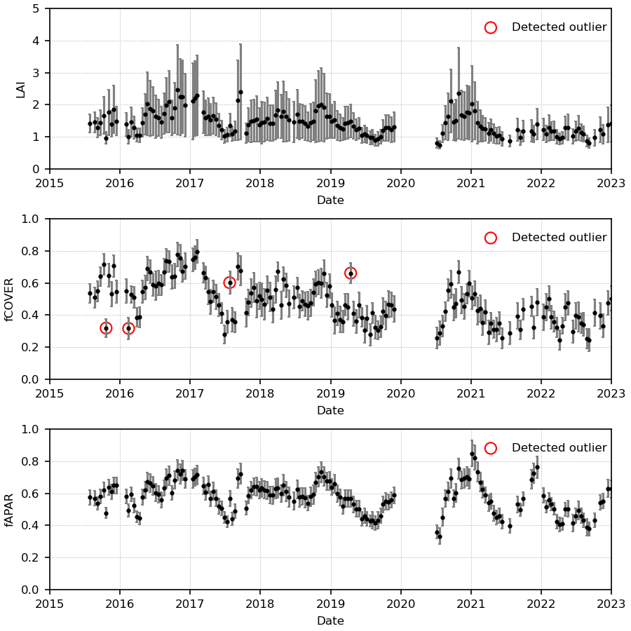

Figure ##: example of outliers detected on RM time series acquired on NEON site ####

Table ##: number and fraction of outliers detected for each variable and NEON site compared to the total sample size.

|  |  |  |  |  |  |  |  |  |  |
| --- | --- | --- | --- | --- | --- | --- | --- | --- | --- |
|  | LAI | | | fCOVER | | | fAPAR | | |
| **Land Cover** | **#samples** | **#Filtered** | **Fraction (%)** | **#samples** | **#Filtered** | **Fraction (%)** | **#samples** | **#Filtered** | **Fraction (%)** |
| evergreen Forest | 3427 | 3 | 0.09 | 3427 | 30 | 0.88 | 3427 | 16 | 0.47 |
| grassland Herbaceous | 2101 | 1 | 0.05 | 2101 | 4 | 0.19 | 2101 | 3 | 0.14 |
| shrub Scrub | 1704 | 0 | 0 | 1704 | 1 | 0.06 | 1704 | 1 | 0.06 |
| mixed Forest | 639 | 1 | 0.16 | 639 | 1 | 0.16 | 639 | 1 | 0.16 |
| sedge Herbaceous | 126 | 0 | 0 | 126 | 0 | 0 | 126 | 0 | 0 |
| emergent Herbaceous Wetlands | 79 | 0 | 0 | 79 | 0 | 0 | 79 | 0 | 0 |
| deciduous Forest | 3923 | 19 | 0.48 | 3923 | 28 | 0.71 | 3923 | 31 | 0.79 |
| pasture Hay | 934 | 16 | 1.71 | 934 | 55 | 5.89 | 934 | 48 | 5.14 |
| cultivated Crops | 702 | 2 | 0.28 | 702 | 16 | 2.28 | 702 | 16 | 2.28 |
| woody Wetlands | 326 | 2 | 0.61 | 326 | 2 | 0.61 | 326 | 2 | 0.61 |
| dwarf Scrub | 180 | 0 | 0 | 180 | 0 | 0 | 180 | 0 | 0 |
| **total** | **14141** | **44** | **0.31** | **14141** | **137** | **0.97** | **14141** | **118** | **0.83** |

Show level=0.5

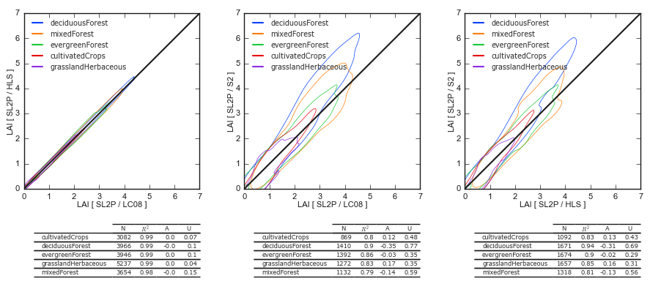

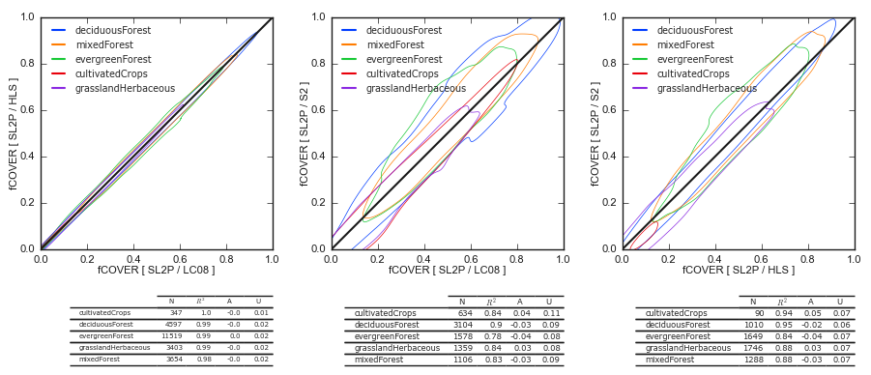

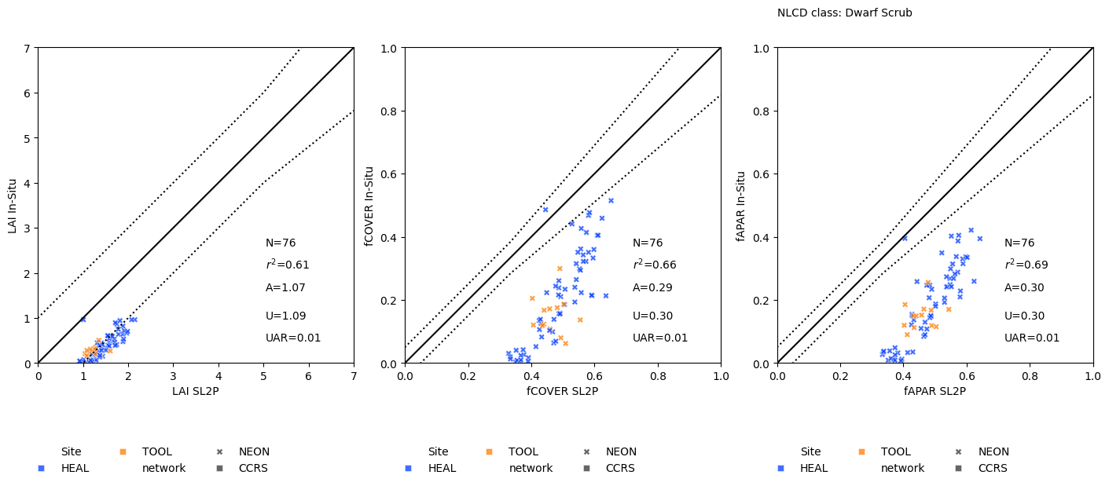

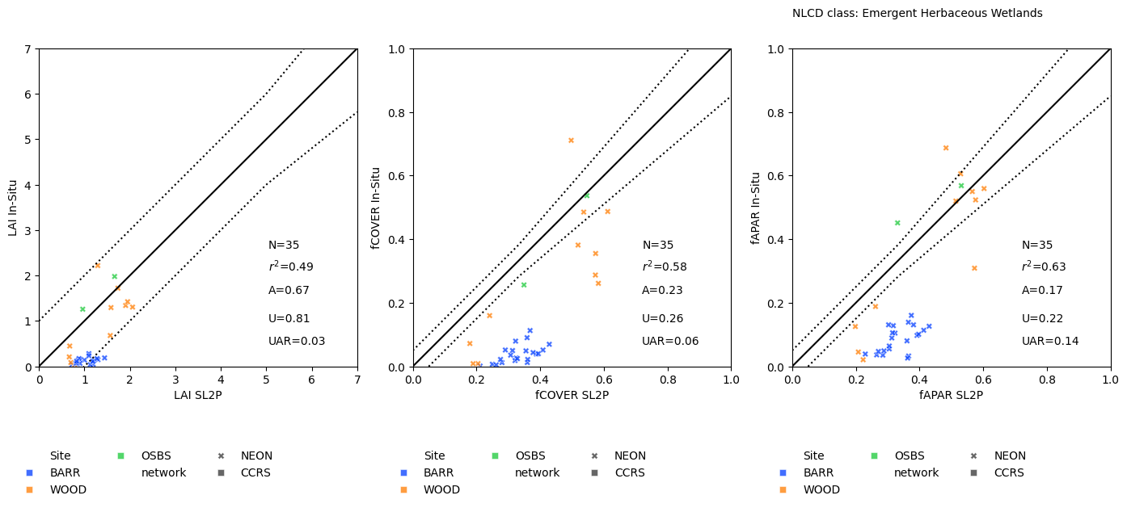

BARR, TOOL, HEAL??

